**S. B. JAIN INSTITUTE OF TECHNOLOGY, MANAGEMENT & RESEARCH, NAGPUR**



(An Autonomous Institute, Affiliated to R. T. M. Nagpur University)

**Department of**

**Electronics and Telecommunication Engineering**

*“Emerge as a center for quality education in Electronics & Telecommunication Engineering, so as to create competent professionals”*

Certificate

This is to certify that the project report entitled “**Doctor’s Appointment System**” is successfully submitted by **Mr. Atharv P. Ganer** to Department of Electronics & Telecommunication Engineering as a part of “Practice School-II: Training on C++ Programming*”* for the Session 2022-23.

Prof. Vivek Deshmukh Project Guide

Dr. M. W. Khanooni Project In- Charge

Dr. Abhay R. Kasetwar Head of Department

**Abstract:**

The purpose of Doctor Appointment System is to automate the existing manual

system by the help of computerized equipments and full-fledged computer software, fulfilling their requirements, so that their valuable data/information can be stored for a longer period with easy accessing and manipulation of the same.

The required software and hardware are easily available and easy to work with. Doctor Appointment System, as described above, can lead to error free, secure, reliable and fast management system. It can assist the user to concentrate on their

other activities rather to concentrate on the record keeping. Thus it will help organization in better utilization of resources. The organization can maintain computerized records without redundant entries. That means that one need not be distracted by information that is not relevant, while being able to reach the information.

The aim is to automate its existing manual system by the help of computerized

equipments and full-fledged computer software, fulfilling their requirements, so that their valuable data/information can be stored for a longer period with easy accessing and manipulation of the same. Basically the project describes how to manage for good performance and better services for the clients.

**Mapping of project title with PO’s:**

|  |  |  |  |  |  |  |  |  |  |  |  |  |  |
| --- | --- | --- | --- | --- | --- | --- | --- | --- | --- | --- | --- | --- | --- |
| **PO** | **PO** | **PO** | **PO** | **PO** | **PO** | **PO** | **PO** | **PO** | **PO** | **PO** | **PO** | **PSO** | **PSO** |
| **1** | **2** | **3** | **4** | **5** | **6** | **7** | **8** | **9** | **10** | **11** | **12** | **1** | **2** |

**3- high, 2- moderate, 1-slight**

**Project Title**

**Title**

**2**

**2**

**2**

**2**

**2**

**1**

**-**

**-**

**1**

**-**

**-**

**2**

**2**

**2**

|  |  |  |  |
| --- | --- | --- | --- |
| PO1 | Engineering Knowledge | PO7 | Environment & Sustainability |
| PO2 | Problem Analysis | PO8 | Ethics |
| PO3 | Design & Development | PO9 | Individual & Team Work |
| PO4 | Investigations | PO10 | Communication Skills |
| PO5 | Modern Tools | PO11 | Project Management & Finance |
| PO6 | Engineering & Society | PO12 | Life Long Learning |

**Description of Project:**

The propose of this project is a smart appointment booking system that provides patients or any user an easy way of booking a doctor’s appointment online.

This is a web based application that overcomes the issue of managing and booking appointments according to user’s choice or demands. The task sometimes becomes very tedious for the compounder or doctor himself in manually allotting appointments for the users as per their availability.

Hence this project offers an effective solution where users can view various booking slots available and select the preferred date and time. The already booked space will be marked yellow and will not be available for anyone else for the specified time. This system also allows users to cancel their booking anytime.

The system provides an additional feature of calculating monthly earnings of doctor. Doctor has to just feed the system regularly with daily earnings and the system automatically generates a report of total amount earned at the end of the month. The application uses Asp.net as a front-end and sql database as the back- end.

**Motivation/Problem statement:**

There are many Doctors who want to open their own clinic. Once that clinic has been establised, the patients start coming to them for medical consultation. Many times it happens that there are a lot of patients in the clinic and quarraling begins among them that who is going to the doctor first. Here the main motive of this project comes in play.

This system helps the doctor to efficiently manage the patients according to their time preferences. This system helps in managing the patients and reducing the work of the doctor.

This system helps in the automation of manual system of writing down the serial numbers of the patients, by using this system, doctor can easily maintain the record of which patient is having which appointment.

This system reduces the work of doctor and help in efficiently managing the patients according to their appointments.

**Methodology:**

* **#include:** this is a pre-processor operative, it basically indicates the compiler to use the line first before anything is processed. Include has the same meaning in c++ as it does in English language.
* **iostream:** a header file which contains certain built in functions. Mostly used for cout and cin. In all the above mentioned functions c stands for console. So cout is console output, cin is console input. Consoles being display device and keyboards respectively.
* **string:** it is used if the program has a string type of data i.e. , characters (eg. names). This contains the library of strings in C++.
* **fstream:** library provides functions for files, and we should simply add #include

<fstream> directives at the start of our program. To open a file, a filestream object should first be created. This is either an ofstream object for writing, or an ifstream object for reading.

* **cstring:** The cstring header file contains defination for C++ for manupulating several kinds of strings. Include the standard header into a C++ program to effectively include the standard header <string.h> within th std namespace.

**using namespace std:** The advantage of namespaces in languages like C++ is that they let different code modules use whatever names they want for variables, methods, etc. without worrying about collisions.

**while loop:** A while loop in C/C++ execute certain set of statement multiple times. Before executing the statement it check whether the condition is true/false, if condition is true it execute the statement present in body of the loop. If condition is false is comes out of while loop.

**if-else:** If else statement is one type of conditional statement. You can simply relate it with real life situation.

**for loop:** A for loop is a repetition control structure that allows you to efficiently write a loop that needs to execute a specific number of times.

**[ifstream](https://cplusplus.com/ifstream):** Stream class to read from files. **[ofstream](https://cplusplus.com/ofstream):** Stream class to write on files **read.open:** To open a specific file.

**Algorithm:**

1. **Create a function for booking Appointment.**
2. **Print message for available slots.**
3. **Create a .dat file.**
4. **Use ifstream read and read.open to open a file for storing data.**
5. **Create an array for available slots.**
6. **Assign each element of the array an initial from A-Z till the last element of the array.**
7. **Give user the choice to select any one initial from the list displayed on screen.**
8. **Enter patient’s name and store(save) it in the .dat file created before.**
9. **Print “Appointment booked” if the time slot is available else print “Error in booking the appointment”.**
10. **Provide a method to go back to the main menu.**
11. **Create a function for printing existing Appointment.**
12. **Print the existing Appointments according to the saved list in previous function.**
13. **Print the list and print “Booked” in front of existing appointment slots and “Available” in front of remaining slots.**
14. **Provide a method to go back to the main menu.**
15. **Create the main program.**
16. **Display choice to the user for accesing the program.**
17. **If the choice is 1, display first function.**
18. **If the choice is 2, display second function.**
19. **If the choice is 3, exit the program.**
20. **If exiting, ask user if they are sure.**
21. **If yes exit the program, if no then print the main menu.**
22. **If the input is inccorect, print error.**

**Flow-Chart:**

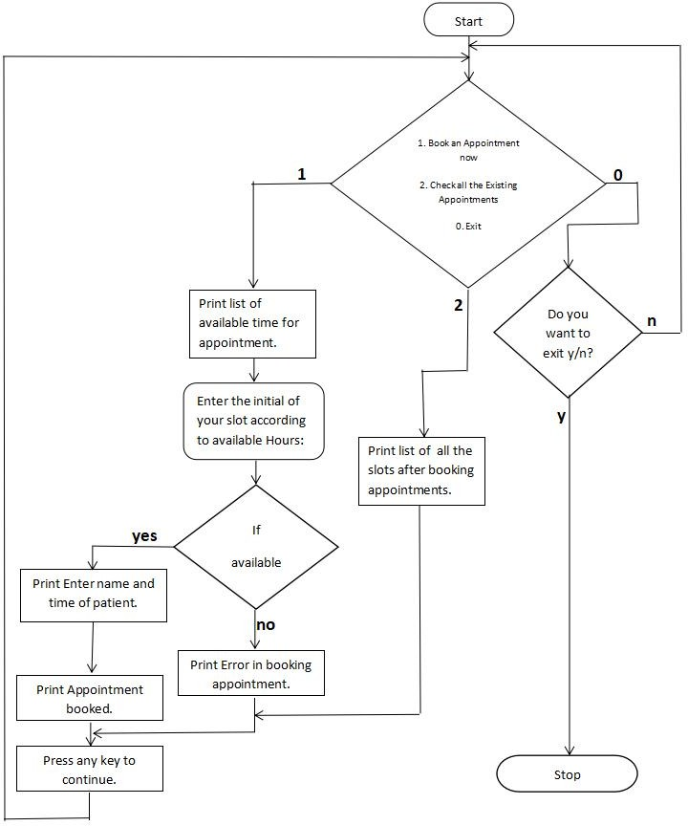

**Code:**

**#include <iostream>**

**#include <string>**

**#include <fstream>**

**#include <cstring>**

**using namespace std;**

**int bookAppointment()**

**{**

**system("cls");**

**cout<<"\n ----- Check and Book Appointment as per available slots ---- \n";**

**cout<<"\n ----- The available slots are---- \n";**

**ifstream read;**

**read.open("appointment.dat");**

**int hoursbook = 9;**

**int arr[14] = {0,0,0,0,0,0,0,0,0,0,0,0,0,0};**

**int recordFound =0;**

**if(read)**

**{**

**string line;**

**char key = 'A';**

**int i = 9;**

**while(getline(read, line)) {**

**char temp = line[0];**

**int index = (temp - 65);**

**arr[index]=1;**

**recordFound = 1;**

**}**

**if(recordFound == 1)**

**{**

**cout<<"Timing: 9am to 10pm.";**

**cout<<"\nTodays appointments.";**

**cout<<"\nAppointment List as per available Hours:";**

**char key = 'A';**

**int hours = 9;**

**for(int i = 0; i<=13; i++)**

**{**

**if(i == 0){**

**if(arr[i] == 0)**

**cout<<"\n "<<key<<"-> 0"<<hours<<" - Available";**

**else**

**cout<<"\n "<<key<<"-> 0"<<hours<<" - Booked";**

**}**

**else**

**{**

**if(arr[i] == 0)**

**cout<<"\n "<<key<<"->"<<hours<<" - Available";**

**else**

**cout<<"\n "<<key<<"->"<<hours<<" - Booked";**

**}**

**hours++; key++;**

**}**

**}**

**read.close();**

**}**

**if(recordFound == 0){**

**cout<<"\nAppointments are available for the following hours:";**

**char key = 'A';**

**for(int i = 9; i<=22; i++)**

**{**

**if(i==9)**

**cout<<"\n "<<key<<" -> 0"<<i<<" - Available";**

**else**

**cout<<"\n "<<key<<" -> "<<i<<" - Available";**

**key++;**

**}**

**}**

**char choice;**

**cout<<"\n\n Enter the initial of your slot according to available Hours: ";**

**cin>>choice;**

**if( !(choice >= 'A' && choice <='Z'))**

**{**

**cout<"\n Error : Invalid Selection";**

**cout<<"\n Please select correct value from menu A- Z";**

**cout<"\n Press any key to continue";**

**getchar();**

**getchar();**

**system("cls");**

**bookAppointment();**

**}**

**int index = (choice-65 );**

**int isBooked = 1;**

**if(arr[index] == 0)**

**isBooked = 0;**

**if(isBooked ==1)**

**{**

**cout<<"\n Error : This Appointment slot is already booked.";**

**cout<<"\n Please select different time slot!!";**

**cout<<"\n Press any key to continue!!";**

**getchar();**

**getchar();**

**system("cls");**

**bookAppointment();**

**}**

**string name;**

**cout<<"\n Enter Patient's Name_Time :";**

**cin>>name;**

**ofstream out;**

**out.open("appointment.dat", ios::app);**

**if(out){**

**out<<choice<<":"<<name.c_str()<<"\n";**

**out.close();**

**cout<<"\n Appointment is Successfully Noted(Booked) for Hour : "<< (choice-65) + 9 <<" !!";**

**}**

**else**

**{**

**cout<<"\n Error while saving booking";**

**}**

**cout<<"\n Please any key to continue..";**

**getchar();**

**getchar();**

**return 0;**

**}**

**int existingAppointment()**

**{**

**system("cls");**

**cout<<"\nToday's Confirmed Appointments:'";**

**cout<<"\n ----- List of Available Appointments ---- \n";**

**ifstream read;**

**read.open("appointment.dat");**

**int hoursbook = 8;**

**int arr[14] = {0,0,0,0,0,0,0,0,0,0,0,0,0,0};**

**int recordFound =0;**

**if(read)**

**{**

**string line;**

**char key = 'A';**

**int i = 9;**

**while(getline(read, line)) {**

**char temp = line[0];**

**int index = (temp - 65);**

**arr[index]=1;**

**recordFound = 1;**

**}**

**if(recordFound == 1)**

**{**

**cout<<"\nAppointment List available as per hours:";**

**char key = 'A';**

**int hours = 9;**

**for(int i = 0; i<=13; i++)**

**{**

**if(i == 0){**

**if(arr[i] == 0)**

**cout<<"\n "<<key<<"-> 0"<<hours<<" - Available";**

**else**

**cout<<"\n "<<key<<"-> 0"<<hours<<" - Booked";**

**}**

**else**

**{**

**if(arr[i] == 0)**

**cout<<"\n "<<key<<"->"<<hours<<" - Available";**

**else**

**cout<<"\n "<<key<<"->"<<hours<<" - Booked";**

**}**

**hours++; key++;**

**}**

**}**

**read.close();**

**}**

**if(recordFound == 0){**

**cout<<"\nAppointment Available for following hours :";**

**char key = 'A';**

**for(int i = 9; i<=22; i++)**

**{**

**if(i==9)**

**cout<<"\n "<<key<<" -> 0"<<i<<" - Available";**

**else**

**cout<<"\n "<<key<<" -> "<<i<<" - Available";**

**key++;**

**}**

**}**

**ofstream out;**

**out.open("appointment.dat", ios::app);**

**cout<<"\n Press any key to continue..";**

**getchar(); getchar();**

**return 0;**

**}**

**int main(int argc, char** argv) {**

**while(1)**

**{**

**system("cls");**

**cout<<"\t\t|Doctor Appointment Booking System|\n";**

**cout<<"\t--------------------------------------------------\n\n";**

**cout<<"1. Book an Appointment now\n";**

**cout<<"2. Check all the Existing Appointments\n";**

**cout<<"0. Exit. \n";**

**int choice;**

**cout<<"\nEnter you choice: ";**

**cin>>choice;**

**switch(choice)**

**{**

**case 1: bookAppointment();**

**break;**

**case 2: existingAppointment();**

**break;**

**case 0:**

**while(1)**

**{**

**system("cls");**

**cout<<"\n Are you sure, you want to exit? y | n \n";**

**char ex;**

**cin>>ex;**

**if(ex == 'y' || ex == 'Y')**

**exit(0);**

**else if(ex == 'n' || ex == 'N')**

**{**

**break;**

**}**

**else{**

**cout<<"\n Invalid choice !!!";**

**getchar();**

**}**

**} break;**

**default: cout<<"\n Invalid choice. Enter again ";**

**getchar();**

**}**

**}**

**return 0;**

**}**

**Tools Used:**

* **Dev C++**

**Result: Learned to use various C++ concepts to build an application.**

**Output Screenshots**

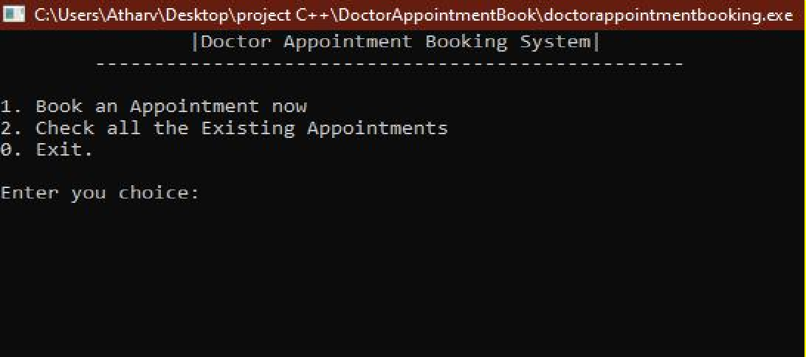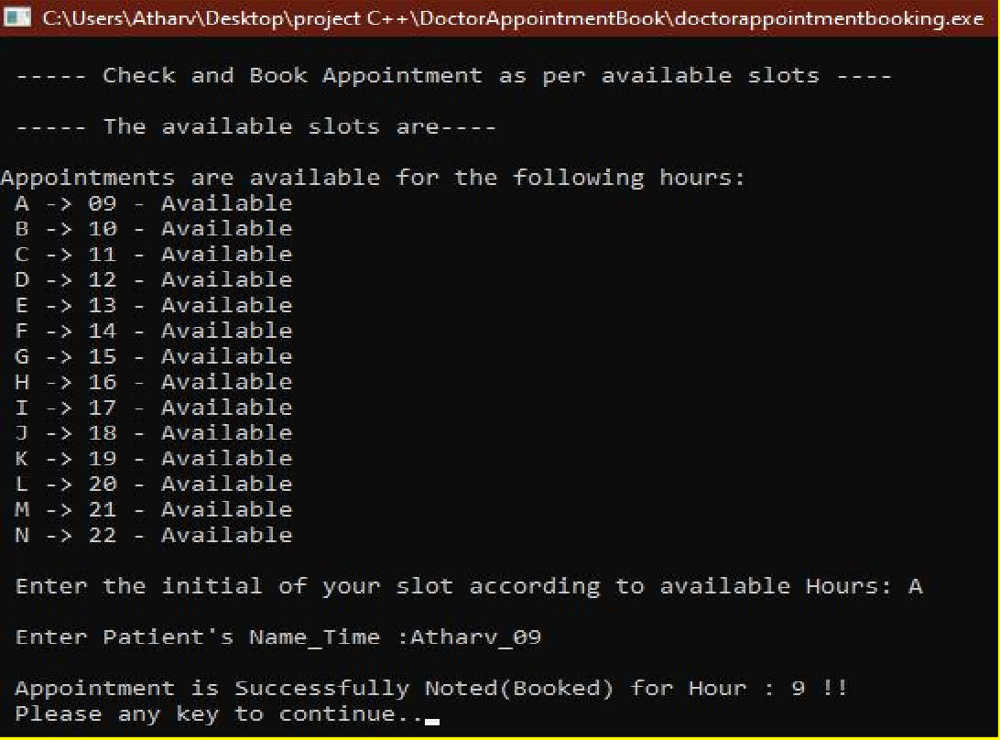

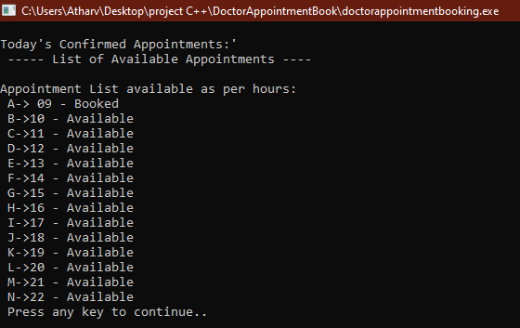

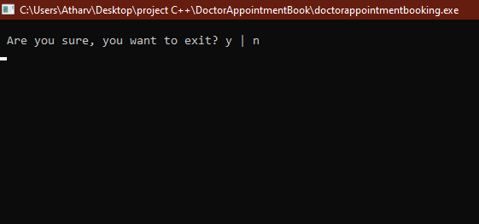

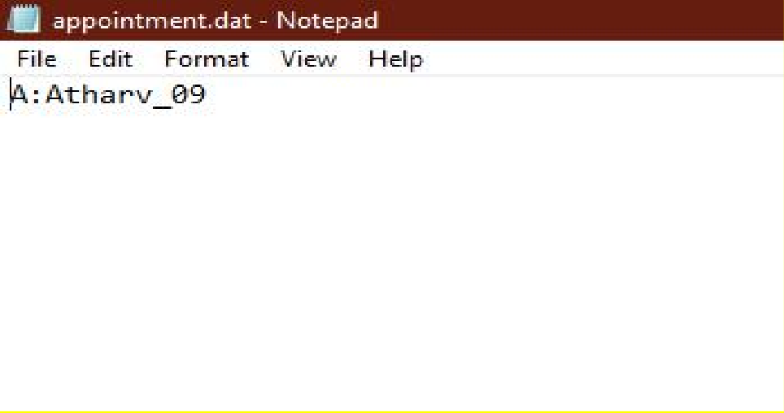

**Conclusion: A “Doctor’s Appointment Booking” application has been developed through C++ language using its basic concepts.**

**References:**

* **<https://www.codecademy.com/profiles/Night_lightAugust04>**
* **[https://codeprojectz.com/applications-and-web-projects/simple-hospital-](https://codeprojectz.com/applications-and-web-projects/simple-hospital-management-system-in-c-with-source-code/) management-system-in-c-with-source-code/**
* **<https://youtu.be/HkzwqXnn69A>**